Q1. JavaScript Coding Practice
1. Check Whether a Number is Even or Odd
Problem Statement : Write a JavaScript program to check whether a given number is Even or Odd.
Source Code
let number = 25;
//let number = 18;
if (number % 2 === 0) {
console.log(number + " is Even");
} else {
console.log(number + " is Odd");
}
Output
25 is Odd
18 is Even
Screenshot: 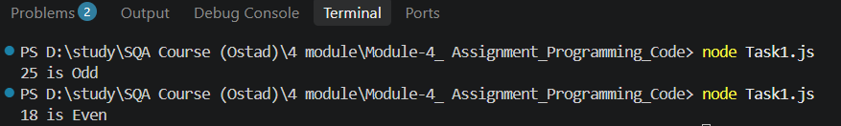
Explanation :
- % is the modulus operator, which returns the remainder.
- If a number divided by 2 has remainder 0, it is Even.
- Otherwise, it is Odd.
- if...else is used to make the decision.
2. Find the Largest of Three Numbers
Problem Statement : Write a JavaScript program to find the largest number among three given numbers.
Source Code
let a = 25;
let b = 40;
let c = 30;
let largest;
if (a >= b && a >= c) {
largest = a;
} else if (b >= a && b >= c) {
largest = b;
} else {
largest = c;
}
console.log("Largest number is:", largest);
Output
Largest number is: 40
Screenshot: 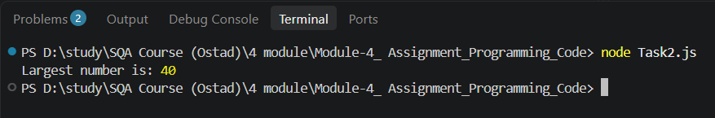

Explanation:
- Three variables a, b, and c store the numbers.
- The if...else if...else statement compares them.
- && means AND.
- The number satisfying both comparisons is assigned to largest.
Here:
25 < 40
30 < 40
Therefore, 40 is the largest number.

───────────────────────────────────────────────

3. Reverse a String
Problem Statement : Write a JavaScript program to reverse a given string.
Source Code
let text = "Tanny Rajbangshi";
let reversed = text.split("").reverse().join("");
console.log("Original String:", text);
console.log("Reversed String:", reversed);
Output
Original String: JavaScript
Reversed String: ihsgnabjar ynnaT
Screenshot: 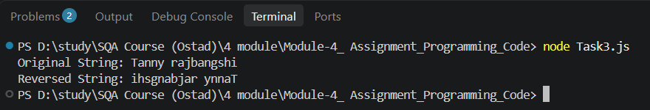
Explanation
This code reverses the string "Tanny rajbangshi" using split(), reverse(), and join().
It then prints both the original string and the reversed string using console.log().

───────────────────────────────────────────────
4. Count Vowels in a String
Problem Statement : Write a JavaScript program to count the number of vowels in a given string.
The vowels are:
a, e, i, o, u
Source Code
let text = "Tanny rajbangshi";
let count = 0;
for (let char of text.toLowerCase()) {
if ("aeiou".includes(char)) {
count++;
}
}
console.log("String:", text);
console.log("Number of vowels:", count
Output
String "Tanny rajbangshi"
Number of vowels: 4
Screenshot: 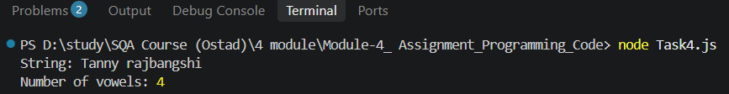

Explanation :
- toLowerCase() converts all characters into lowercase.
- for...of checks each character one by one.
- "aeiou".includes(char) checks whether the character is a vowel.
- Whenever a vowel is found, count increases by 1.

───────────────────────────────────────────────

5. Remove Duplicate Values from an Array
Problem Statement : Write a JavaScript program to remove duplicate values from an array and display only the unique values.
Source Code
let numbers = [10, 20, 10, 30, 20, 40, 30];
let uniqueNumbers = [...new Set(numbers)];
console.log("Original Array:", numbers);
console.log("Array without duplicates:", uniqueNumbers);
Output
Original Array: [10, 20, 10, 30, 20, 40, 30]
Array without duplicates: [ 10, 20, 30, 40 ]
Screenshot : 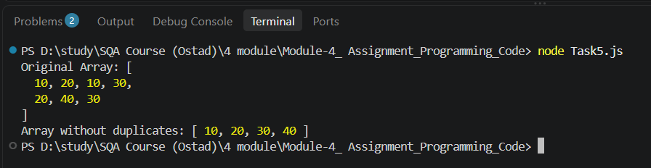
Explanation :
This code removes duplicate values from the array using Set.
It then prints the original array and the array with unique values only.

